

The Magazine of Shawlands Trinity Church

Dear friends,
By the time you read this I will have been with you at Shawlands Trinity as locum for over four months. I have enjoyed being part of the congregation and appreciated the way you’ve welcomed me into the church family, your homes and your lives.
But how the time has flown. When I arrived, Lent was just about to begin; now we are already past Easter, with Ascension Sunday and Pentecost behind us. Alongside the rhythm of the church year, there has been so much else: the Brownies coffee evening, the Boys' Brigade annual display, the family fun day, various Christian Aid events, as well as the weekly Warm Café, and all the clubs and groups that bring people through our doors day by day. And there is more to come before summer. Sunday 14th June is the annual Prizegiving Service, which falls on the same day as Bring a Friend to Church Sunday, when you are encouraged to invite someone who hasn't worshipped with us for a while, or perhaps ever.
It’s a busy church! I continue to be impressed by how much life there is here: the number of things that happen, the young people who come through the doors every week, and the passion and commitment you show for this parish and its people.
In my Ascension Sunday sermon, I mentioned that the roll of our church stands at around one hundred and twenty people – the same as the number of disciples gathered in Jerusalem after Jesus ascended. That may not seem many compared to the old days, but as the Book of Acts shows, that number of people can do remarkable things when they live out their faith with boldness and love.
The outgoing Moderator of the General Assembly, the Very Rev. Rosie Frew, put it memorably in her retiring address. If every member of the Church of Scotland – a quarter of a million people – were given a single Lego brick, what could be built? So what might be possible, she asked, if all those people shared the good news by showing love, care, and compassion? Just think what we could do here in Shawlands, across Scotland, and beyond.
With every blessing, Allan.
The Brownies
Both Brownie Packs have been keeping busy and have now completed the Skills Builder Influence Stage 2 Badge.

Most of our Brownies are looking forward to a Sleepover at Flip Out at the end of May.

Many thanks to everyone who supported our Coffee Evening when £230.00 was raised.

We are having our Parents' Evenings on 8th and 10th June. Anyone is most welcome to join us.

We are losing a good number of girls in both Packs as they move on to Guides or other activities. We are urgently looking for new members to join both Packs.

Many thanks for saving used postage stamps for the Packs and many thanks for all your support this past Session.

Hope you all have a lovely summer.

Ann

Interim Moderator Stuart Crawford 239 2140
Email scrawford@churchofscotland.org.uk

Session Clerk Team Brian McAlinden 6321885 Eleanor McLintock 649 6068
Scot van den Akker 571 6399

Roll Keeper Ian Cuthbertson 632 8101

Treasurer Lilian Craig 649 2237

Halls Convener Christine Cuthbertson 632 8101


Notes

Langside Heritage Trail – 28th March


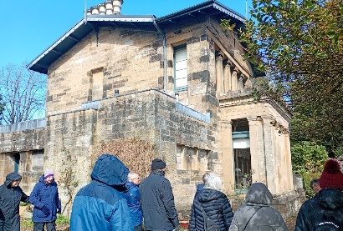
At last there were clear signs of Spring! After starting off from the bottom of Mill Brae and meandering along the remarkable ‘Thomsonesque’ Crescent we were brought to a stop by a sudden heavy hail-storm! Nothing daunted, we carried on up the hill to Mansionhouse Road, site of several notable houses, where we were forunate enough to encounter the occupant of No 25A (one half of the unique Greek Thomson Double Villa) who invited us to come in for a closer look and was able to expand on the history of the area. (That was quite a rare priviledge since the house is rarely open to the public.) But it was cold. So we terminated our tour at the site of the old village of Langside where we were able to appreciate some of the work of Alexander Skirving (including the Monument, 1887) before retiring to the Langside Café.

Dollar to Tillicoultry – 25th April

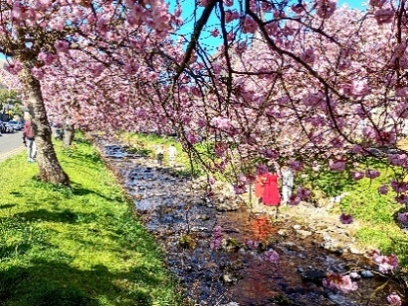
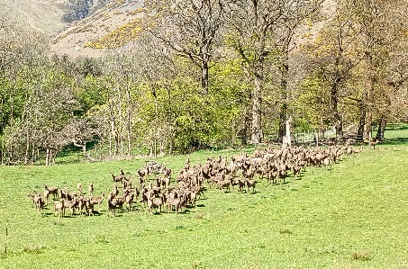
First stop was the Burnside in Dollar. I had thought we might be a bit too late to see the glorious display of blossom – but we were not to be disappointed! A brief but interesting visit to the recently opened Wee Bookshop (cum café) then an easy stroll along the Back Road to the Harviestoun Estate with a real treat on the way – two whole fields of deer! Then down to the River Devon and so to the Sterling Mills in Tillicoultry, and an easy return to Dollar, courtesy of the new community bus. Short but sweet!
Linlithgow – 16th May

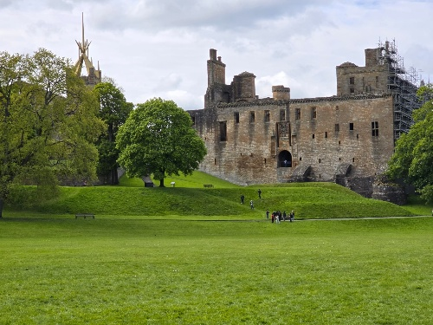

A bit of a late arrival in Linlithgow due to hold-ups of one kind or another, so when we’d all arrived at our destination we were all raring to be off. One group ventured up to the Union Canal heading for the Avon Aqueduct – a very easy walk in very pleasant countryside. Built in 1821 (with advice from Thomas Telford) the aqueduct is most impressive and has 12 arches. Only one of our number was brave enough to cross by the narrow tow-path! After a delightful stroll down the River Avon we reached the Avon Viaduct (1841, 20 arches!) at Linlithgow Bridge. Meanwhile, a second group completed the walk round Linlithgow Loch and spent time soaking up the history of The Palace (from the 14th century). A visit to Costa rounded off a most enjoyable day.

Next Walk: Alloway, Sat 20th June

Bill Craig at billcraig38@gmail.com or 649 2237

Congregational Register
Deaths
‘I am the Resurrection and the Life”

23rd April
Mrs Evelyn Kennedy District 5

23rd May
Mr David McLachlan District 7



The Secret of the Third Monk

Psalm 46:10, Isaiah 30:15

In a review of her own recently published book, Tish Harrison Warren relates this story:-

“In the sayings of the Desert Fathers and Mothers, there’s a strange story. There were three friends who were monks, all earnest and faithful. One of them, motivated by the call in Matthew’s Gospel to be a peacemaker, chose to spend his time seeking to “make peace between men who were at odds.” The second monk, motivated by Christ’s concern for the vulnerable, decided to “visit the sick.” The third chose to “go away to be quiet in solitude.”

“The first monk did some good helping others to reconcile, but he grew sad over conflicts he could not solve. He felt “overcome with weariness.” So he went to visit his friend who was tending the sick, only to discover that his friend, too, was “flailing in spirit.”

“The two men visited the third monk and told him about their exhaustion and sense of futility – what today we might call burnout.

The third monk sat silently for a long while, then he poured water into a cup. “Look at this water,” he said. The water was murky with silt. But after they sat together for a while, the water settled. “See now, how clear the water has become,” said the third monk. “So it is with anyone who lives in a crowd; because of the turbulence, he does not see his sins: but when he has been quiet, above all in solitude, then he recognizes his own faults.”

Tish goes on to comment:-

“Each time I read this story, I want to argue with it. Don’t some of us have to live in crowds? Doesn’t someone have to make peace? Doesn’t someone have to visit the sick?

“Yet that’s exactly what intrigues me about this story: how countercultural and counterintuitive it is to me. The first and second monks are motivated by such good and virtuous things. Their work is urgent and important. If this parable were told today, they would be the clear moral heroes, pouring themselves out in service to others. Yet despite their passion, or maybe because of it, they find themselves overcome by weariness and discouragement. Their solitary friend implies that they’ve lost perspective. They cannot see themselves, their faults, or their limitations clearly. What they need is withdrawal and quiet.

“In college, I became unlikely friends with a chain-smoking Franciscan priest. Like all Franciscans, he’d taken a vow of poverty. He was brilliant and kind, and I could not doubt his commitment to the marginalized. Soon after graduation, I bumped into the friar, and we caught up. I told him about my job running a church-based program for recent immigrants, which provided tutoring and ESL classes for kids and help for families in poverty. It was beautiful and rewarding work, but also intense, difficult, and draining. A few minutes into our conversation, he looked at me with compassion and said matter-of-factly, “You don’t have the life of prayer and silence necessary to sustain the work you are doing.”

And on her own reaction, Tish says:-

“I was taken aback. What does he know? I thought. I was zealous and passionate about seeking justice and helping others – perhaps a little like the first two monks. My friend was not telling me to quit my job, but he was calling me to learn to be more like the third. And, in the end, he was right. Within a couple of years, I was burned out and discouraged. I had been all energy and fire, but I simply did not have the practices of prayer and solitude necessary to cultivate the wisdom, humility, and stability of heart that my life and work demanded.”

An all too common trap(!), which can only be avoided by taking time out and having the space to do some seriously hard reflection.

Tish Harrison Warren is an American Anglican priest and the new book referred to is What Grows in Weary Lands: On Christian Resilience, (Convergent Books, 2026)
Sunday School and Youth Group
We’ve had another busy and enjoyable year, and we would like to thank our wonderful team of volunteers for all their hard work and support of our young people, and of one another, throughout this session. We have loved learning together and learning from each other along the way.
In Sunday School, our young people have been exploring God and Jesus in a variety of ways. Alongside reading and watching videos about Bible stories together, we’ve enjoyed plenty of games, a wide range of crafts, puzzles, drawing, colouring, and much more. During the first half of the session, we particularly enjoyed using the Scripture Union Scotland resources based on the animated 2025 film ‘The King of Kings’.
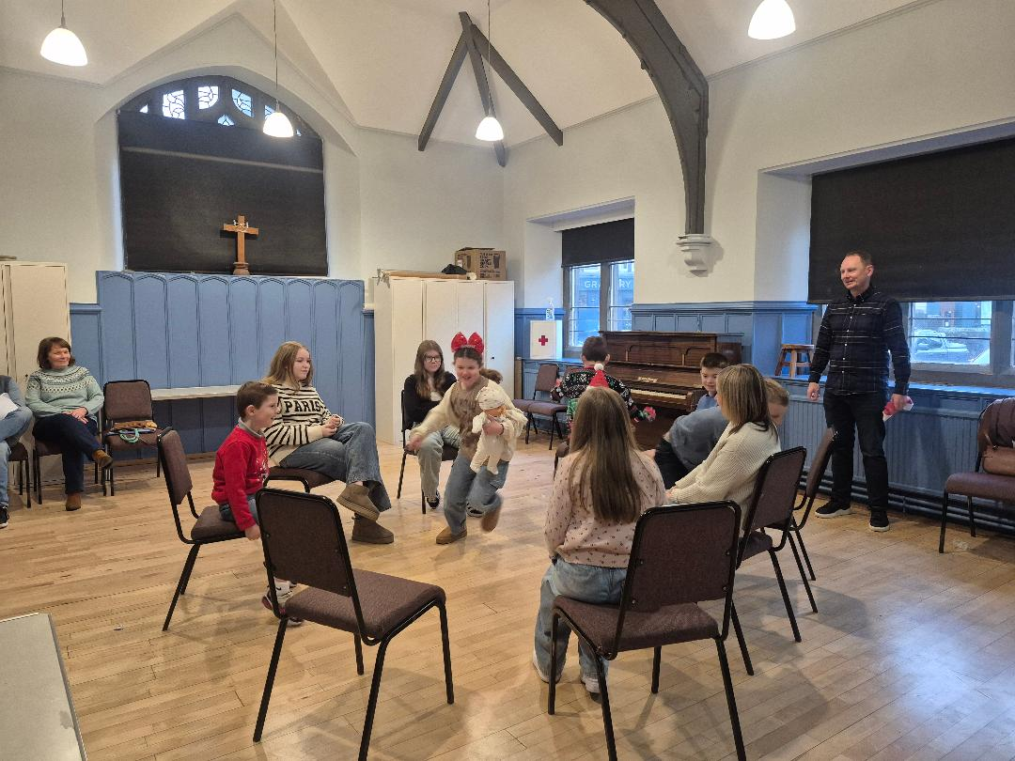
Our Youth Group has also had a positive and engaging year. Our young people have enjoyed spending time together watching, learning, and discussing through The Bible Society’s new Bible Course, which launched in 2025.
We have been especially pleased to welcome some new young people to Sunday School this session, including our locum Allan Lafferty’s children, Aditi and Alexander, who were already familiar faces within our congregation.

Our Nativity Play was a real highlight for all involved. Thank you to everyone who helped make it such a success, and especially to our resident Nativity expert, Joyce McAlinden.
The Youth Group also thoroughly enjoyed their Christmas trip to an escape room.
In January, all of our young people had great fun watching the full King of Kings film and sharing pizza together after church.
We have also valued the opportunity to take part in the All-Age services held throughout this session. Thank you all for your patience, encouragement, and willingness to embrace new ideas. We are also grateful to Rock of Ages for providing music at these services.
Some of our Sunday School members also took part in our church’s well-attended and warmly received holiday club on 11th August 2025, where our theme was ‘All I Need’. We also held a successful and well-supported Family Fun Drop-In on 7th May 2026. Our thanks go to everyone who volunteered their time to lead activities and support both events. We are now planning another family event for October 2026.
By the time you are reading this, we will be looking ahead to our Prize-giving on Sunday 14th June, which will mark the end of our 2025–26 programme. Our 2026–27 session will begin on Sunday 16th August.
Thank you to our congregation for your continued encouragement and support. Please keep our leaders and young people in your prayers as we continue this journey together.
Elaine van den Akker


45th Boys’ Brigade
As we draw near to the end of this year’s session and head into summer, it has been yet again a very busy and successful year for the 45th as you will have read in previous church articles.
Our end of year display and awards night was no different. This gave the boys a chance to showcase their many skills & talents. From the Anchors enthusiastic singing, the Juniors faultless figure marching, our amazing ‘chanter’ boys to the outstanding achievement of our Company Section table tennis team……and we managed to get ourselves a fantastic new minibus. What a year!
As we move towards our summer break in the next couple of weeks, our Company Section boys look forward to their annual summer camp at Boat of Garten in July. The Juniors & Company Section [P7’s] will once again enjoy a weekend residential at Glenbeg Bunkhouse near Granton on Spey in September.

We would like to thank everyone who supported our two fundraising events, our Big Brunch in January and our night at Shawlands Bowling club in March.

As the staff take some time out for a well-earned break, we look forward to returning in September refreshed and rejuvenated for another amazing year ahead.

Debbie

A date for your diary
Sunday 14th June
BRING A FRIEND TO CHURCH DAY
Everyone Welcome

Material for the Autumn issue of The Link should be in by Sunday 16th August at the latest.

Neerja
John 15:13 Greater love has no one than this: to lay down one's life for one's friends.
1 Corinthians 10:24 Let no one seek his own good, but the good of his neighbour.
Proverbs 3:27 Do not withhold good from those to whom it is due, when it is in your power to do it.
We all know passages from scripture which urge us to put others first; to refrain from being selfish; to be strong when others are weak. But would we do it if the worst came to the worst? We all like to think we would have stood up to the Nazis, or the Soviets, marched against racism, or been imprisoned to distribute Bibles where they are banned. It is much harder to act upon this belief than to talk about it.
Which brings us to Neerja Bhanot. Neerja was born in India in 1963 to a Hindu family. When her father, a journalist, moved the family to Bombay she had the unusual distinction of attending the Scottish School – founded by and run by Scottish Presbyterians – and St Francis Xavier College – run by the Jesuits! Her father wrote for the famous and widely read ‘Hindustan Times’. Due to her father’s contacts, she had done some modelling, for tooth paste among other things.
In 1985 young Neerja saw an advert for Pan Am air crew for a new Frankfurt to India routes. Being educated, beautiful, and charming she was accepted and trained in Miami. She was also escaping an arranged marriage as her spouse had beaten her and rarely for an Indian woman at that time she walked out. Friends said she had informally started dating again by the summer of 1986.
She was designated a purser after training ended and began her duties in 1986 aged 22. On September 5th, 1986, her Pan Am Boing 747 was hijacked by the Palestinian terrorist group The Abu Nidal Organisation.
Neerja very quickly pressed cockpit alert switch, and the crew sealed the cabin and escaped – grounding the plane. As others panicked, she had foiled the terrorists within minutes. Neerja – at 22 – then assumed responsibility for the crew and passengers. The hijackers wanted Americans and Israelis – and quickly identified and shot an Indian American and threw his body out the exit door. Neerja was ordered to gather some crew and seek US passports so that the passport holders could be shot. Incredibly – despite the armed terrorists threatening them – Neerja and her friends hid 43 US passports under seats, down garbage chutes and in overhead lockers.
She then spent hours, as passengers remembered, serving food and drink, chatting to the sacred and nervous, playing with kids, and oozing calmness.
After 17 hours the hijackers realised they were going nowhere and no-one would negotiate so they blew up their backpacks and opened fire with their machine guns. Neerja did not hide. She opened an emergency door and shouted at passengers to get out; she assisted the elderly and as a gunman approached, she stood in front of three children, allowing them to escape. She was shot dead by the emergency exit. She would have been 23 the same week.
Her brother later recalled a family meal when she talked about Miami and the training for a hijack. Her mother said, “You run away, that is what your mother wishes” and Neerja replied: “But mother, what if all mothers thought like you? What would become of us all? You can’t run; you need to face death”. He went on: “As the situation unfolded my mother said to me that she was not coming back as she would never give in and let passengers suffer if she could do anything about it”.
Neerja was awarded India’s highest civilian award for bravery, the Ashoka Chakra, and was the first woman to receive it. To this day Pan has a charitable foundation in her name.
The worst came to the worst for Neerja, and she chose service, discipline, the common good, and defying bullying. Would we?
Scot
Shawlands Trinity Church – Scottish Charity SC012969

